The Care and Feeding of ___
By _____

Introduction
Hello!
To preface, thank you. I really appreciate your taking the time to read this. If I’m sending this to you, you’re almost certainly a wonderful person who is very important to me and who has been there for me during tough times. Thank you so much for being a part of my life and for letting me be a part of yours.
So, what is this and why does it exist? It’s a manual to help me when I’m struggling. Writing this out helps me clarify my self-care practices and help the people closest to me navigate the potential complexities of my health.
This document will encompass a brief overview of my health, links to outside self-care resources, a road-map of how to help me in certain situations, and comics that I thought were relevant. Hopefully it’ll also be funny in some places, and informative in a lot of areas.
A Brief History of Time(s I’ve struggled)
Here you can write a history of your mental illness. Getting diagnosed, treatments you’ve tried, anything you’d like to remember or tell people so they have the necessary background on you.
Information about Depression and Anxiety
Author’s Note: These are specific links for Depression and Anxiety. Feel free to remove and/or replace as many as needed.
Assorted Links about the diseases themselves/how to care for people with them
- https://www.webmd.com/depression/guide/major-depression#1
- https://www.webmd.com/anxiety-panic/guide/anxiety-disorders#1
- https://www.psycom.net/depression.central.html
- https://www.psycom.net/depression.central.anxiety.html
- https://www.nimh.nih.gov/health/topics/depression/index.shtml
- https://www.everydayhealth.com/depression/guide/
- https://adaa.org/understanding-anxiety
- https://www.mayoclinic.org/diseases-conditions/depression/in-depth/depression/art-20045943
- https://www.psycom.net/helping-someone-depressed
- https://www.headway.org.uk/about-brain-injury/individuals/effects-of-brain-injury/executive-dysfunction/
- https://schools.au.reachout.com/articles/developing-a-self-care-plan

Relevant Pop Culture/Media
Below is a list of various media that depicts Anxiety/Depression accurately
Warning: Spoilers, and since all of these deal with some form of mental health, make sure that you are in a headspace to deal with this
- One Day At A Time: Season 2, Episode 9: Hello, Penelope
- Bojack Horseman: Season 4, Episode 6: Stupid Piece of Sh*t
- Jane The Virgin: Season 2, Episode 8: Chapter 30 & Season 3, Episode 12: Chapter 56
- Crazy Ex-Girlfriend: You Stupid B*tch
- Steven Universe: Mindful Education
- Avatar: The Last Airbender and The Legend of Korra: Zuko/Korra Alone
- The Hilarious World of Depression

Typical Symptoms I Experience
- Dizziness/Headaches
- Nausea
- Panic Attacks
- Restlessness
- Seeming ‘out of it’ or just generally really spacey
- Irritability/Angry Outbursts
- Random Crying
- Sadness/Emptiness/Hopelessness/Worthlessness
- Loss of Appetite
- Overeating
- Isolating myself
- Dehydration
- Low Energy/Fatigue/Loss of interest in anything
- Insomnia and inability to leave my bed
- Inability to complete basic tasks (Executive Dysfunction)
- Forgetfulness and/or loss of concentration
- Excessively nice to people
- Being really quiet for long periods of time or just seeming ‘shut down’
- Back/Shoulder/Leg Pain

Common Stressors
  - Family
  - Job Search
  - School Anxieties about the future
  - Personal relationships
  - Seasonal Changes
  - Politics
  - Romantic Relationships

What To Do
Here you can list suggestions for what you/other people should do when you’re struggling. I currently have a list of general statements and walkthroughs of situations, feel free to change and/or modify these for your own needs.
At any point when I’m having a(n) episode, make sure that you are okay/taking care of yourself.
First, are you in a good place where you can/want to be helpful and/or supportive?
  - If Yes, continue on
  - If No, tell me that you need to take care of yourself right now/are busy etc.
Don’t say this: https://www.psycom.net/depression.central.6.things.never.say.html
General Opening Statements:
Great ways to reassure me/start a conversation
- Tell me what I can do to help
- You are important to me
- I am here for you
- We will get through this together
- You’re going to be okay
- This is not your fault

Probable situations:
- I’ve just texted you that I’m having a bad/rough/tough day
  - Reassuring messages (see opening statements)
  - Positivity about the future/reminders of positive things about the past
  - Remind me to take care of myself
  - Go through the Basic Needs Checklist
  - If possible (for both of us) try to schedule an in-person meeting
- I’m having a panic attack
  - Deep Breathing (counting in and out)/Meditation
  - Logically think/talk through the scenario
  - Water (wash face/shower/drink water)
- I’m depressed and crying
  - Get me tissues. My nose starts running when I cry.
  - Let me vent.
    - If the issues are rational, talk through them
    - If they’re not, try to dispel them as much as possible (they probably will be irrational)
  - Hug/Hold me
  - Humor – slowly move conversation to something else positive and then try to do something fun/happy
- I’m depressed with low energy (not talking/leaving my bed)
  - Just sit with me
    - If you choose to start talking: Understand that I may not want to talk very much so feel free to just keep talking about you and I’ll do my best to listen. If you want, ask questions and I’ll try to answer as much as possible
    - If you don’t want to talk: just sit with me. I’ll open up a little eventually but I may not have the energy to really have a conversation
  - Hold/Hug me/pat my hair (any sort of positive physical contact)
  - Go through the Basic Needs Checklist and celebrate tiny bits of progress
  - Humor – slowly move conversation to something else positive and then try to do something fun/happy
- I’m angry/upset
  - Let me vent
  - I’ll probably start crying out of frustration so just follow the rest of ‘I’m Depressed and Crying’ instructions
  - Might turn into Depressed with Low Energy so in that case follow those instructions
Positive affirmations:
- Physical Contact: Hugs, holding me, patting hair. Any sort of positive physical contact. I’m usually pretty cuddly, though there might be times when I don’t want to be touched. I will tell you if it’s the latter (which happens rarely) so physical contact is a good place to start.
- Compliments: Seriously, any sort of compliments, but here are some suggestions:
  - Reiterate the things from the General Statements.
  - Tell me what you like about me
  - Remind me that people care about me
  - Remind me WHY people care about me
  - “You’re a good person who brings a positive impact to the world b/c ___”
  - Tell me why/what you’re proud of me for
  - “You are so strong/brave etc. for ___”
  - List things I’ve done well/correctly
  - Positivity about the future
  - Good memories you have of me
  - Hopes for the future
- Reminders:
  - Depression makes you feel like you don’t deserve anything/are worthless/your failures and the disease is your own fault. This is all completely false but I will forget that.
  - This is not your fault. You will be okay. Etc.
- Things to do: Here are some things that I have set up to help me. Remind me of them
  - Screenshots of positive messages (I keep them on my phone)
  - Lists of funny/happy things
  - This Instagram account: https://www.instagram.com/4amshower/
  - Positive words
  - Once I’m feeling a little better, being around people/socialization helps a lot
  - Once I’m feeling a little better, move me to a new location (even just moving from bedroom to living room will be good, or leaving to get food, or going for a walk, whatever gets me moving and in a new place a little bit)
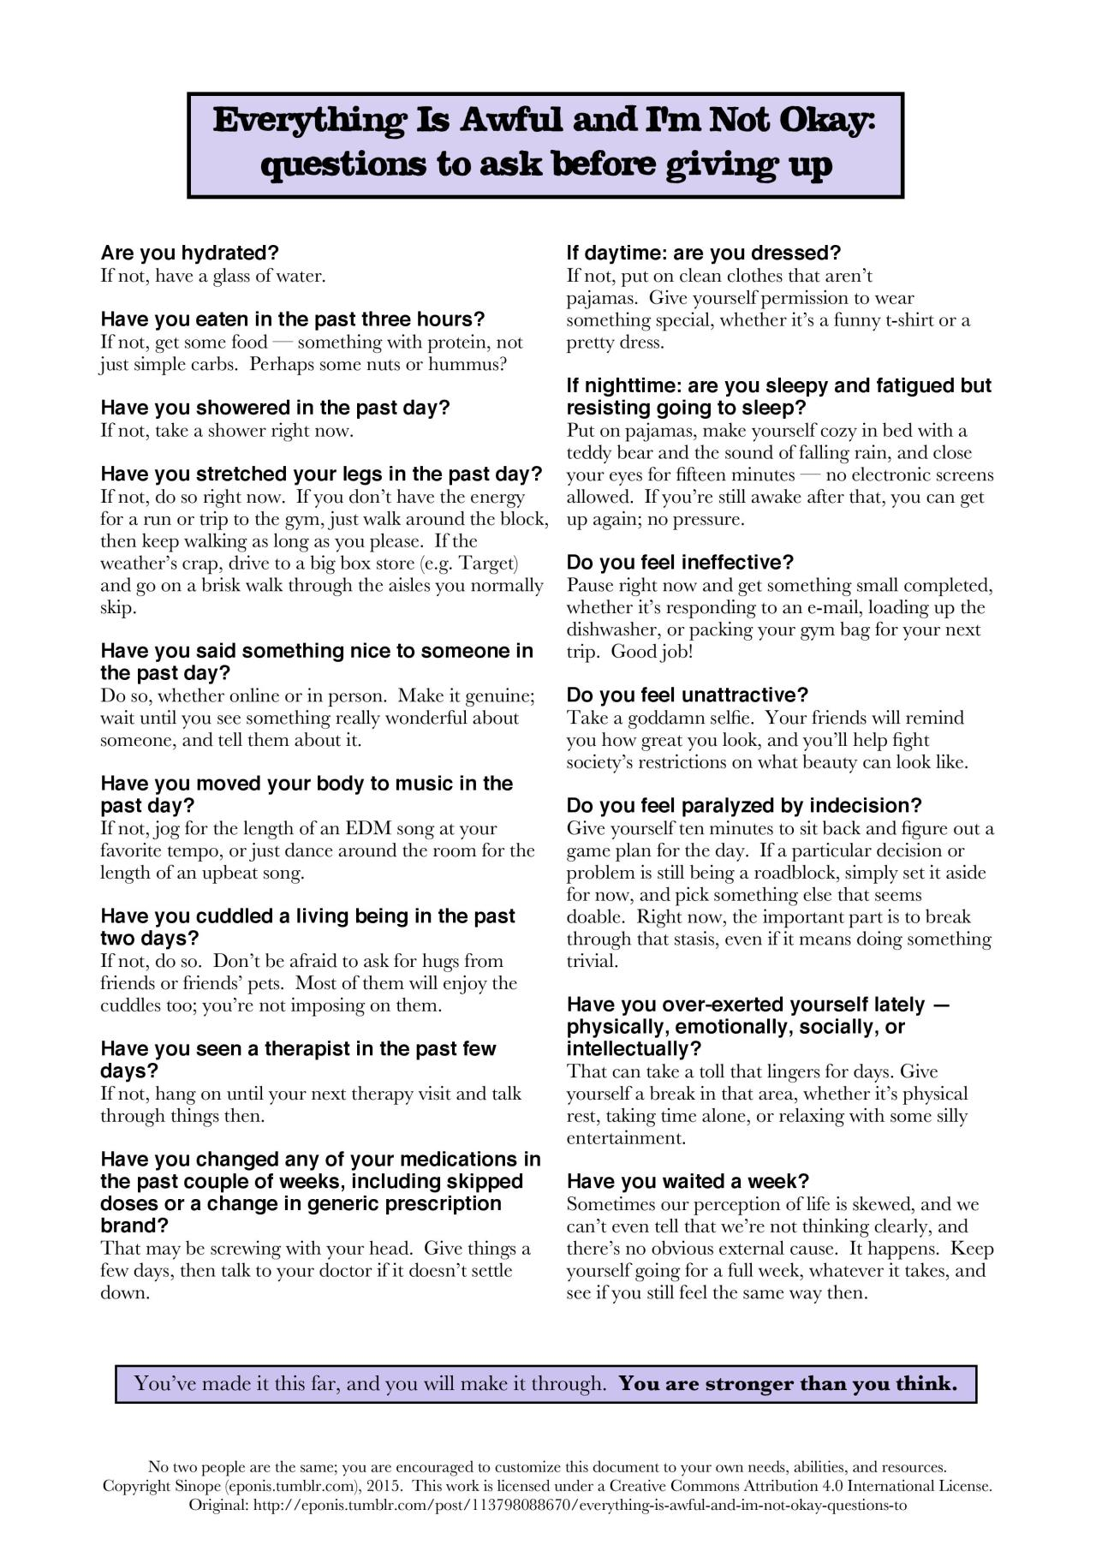
Basic Needs:
In general, I tend to forget my basic needs when I’m depressed. Once the worst has passed and I’m calm/relaxed/energized/rational enough (have been able to breathe normally for 5-10 minutes, have stopped crying, have laughed a little bit, seem up to doing things, ask for help with the following or respond positively to a query about doing one of the following) please prompt/assist me with basic tasks such as:
- Getting out of bed
- Putting on clean clothes
- Drink water
- EAT (seriously, this is a huge one. I forget to eat all the time)
- Walk a little bit
- Wash face (or on worse days, brush teeth and shower)
- Complete small task and celebrate it (this can include any of the above)
Typical Timelines:
- Panic Attack/Anxiety: < 1 hour usually
  - Can take < 1 hour afterwards to calm down completely
- Depression
  - Usually 1-2 bad days leading up to a serious emotional crash
  - Generally, lasts a few days to a week at a time
  - Can last for a month or more at worst
  - Typical bad episode will be a few hours but if I have help/support I can get back to a functioning level within the day

Additional Resources
- Positivity
  - https://imgur.com/gallery/2HTwmnf
  - https://imgur.com/gallery/kLMwy
  - https://imgur.com/gallery/rYKsl
  - https://imgur.com/gallery/2cUWc
  - http://risagablog.tumblr.com/tagged/words

- Self-Care
  - https://www.buzzfeed.com/annaborges/happiness-tips?utm_term=.cx9jEeGDG#.ew1kxDgzg
  - http://philome.la/jace_harr/you-feel-like-shit-an-interactive-self-care-guide/play

- Mental Health
  - http://sheisrecovering.com/post/147965416858/self-soothing-techniques-click-each-slide-for

Helpful Pop-Culture/Media
These help me feel better because they put me in a calmer and happier state of mind
- Parks and Recreation (Netflix)

Favorite Foods
- If I haven’t been eating enough:
  - Something easy to make
    - Cereal
    - Sandwich
    - Peanut Butter
    - Chips and salsa
  - Filling meals
    - Eggs
    - Tofu
    - Lentils
    - Rice
    - Potatoes
  - Takeout
    - Pho
    - Basil Fried Rice
    - Burrito
    - Samosas
  - Comfort Food
    - Chocolate
    - Pasta
    - Cheese
- Foods to avoid

In Case of Emergency
- National hotlines: https://www.healthyplace.com/other-info/resources/mental-health-hotline-numbers-and-referral-resources
- Who To Call
  - Here you can list close friends, medical providers, family, and/or other people that are good contacts for when you’re struggling

